Use Case Diagram

Ethan Dunzer

MIS 312

04/18/2021

Introduction (student to instructor)

The idea of this assignment is to take the broad business processes that were listed in the last assignment and turn them into working use cases. This mostly cleans up and combines multiple processes into one use-case, but it also refines the details about how a process will be used in a use-case.

These cleaned up use-cases will be the solidified system functions that need to take place in creating the final version of this project. Or in other words these are the main needs of the APC team in order for them to function better and achieve their growth goals without overextending themselves with too much system infrastructure.

Every use case is used as a combination of processes that are were brought to my attention by the employee testimonies about their individual roles at APC. These testimonies stated there day to day routine along with known problems that they had during those day-to-day routines. These problems and overall routines were then listed out as processes and then converted into use-cases. Many of the processes that were stated individually by employees could be resolved and updated to the new system through a single use-case. There were multiple instances where this was the case and often, they had to do with the digital record keeping system that will part of the overall system.

Organizing requirements into high level business processes

Business processes are a collection of linked tasks that together will create a service or product that the business will then give to the customer. These are normally small activities that works will do on a daily basis to fulfill the companies working needs. Now the level of these processes can differ based on the employee level, but they are always important to completing day to day tasks for an end goal of the business. For example, APC has many business processes that revolve around paperwork, and each of those instances where an employee files, or completes paperwork they have being using a business process.

The following high-level business processes will be what the APC system will focus on and strive to accomplish. Overall, these 6 processes are combinations of smaller low-level processes that could be fixed/solved by creating a single process. For example, a single low-level problem that APC was having was lack of information when presenting manuscripts to their Collective Members. In order to solve this the Digital Manuscript system was created where all important documents from other processes will be combined into a single portfolio. This high-level process will actually be supported by the other high-level processes such as marketing portfolio which will organize marketing and distribution information which is then sent in the manuscript packets.

- Digital Finance system
- Digital Inventory tracking
- Digital Marketing portfolio's
- Digital Contract system
- Digital Manuscript system
- Digital Publishing system

Use Case Diagram (NAS to APC)

The new system not only has to upgrade hardware components of their current system but also the functionality of it. In order to streamline their new business processes, they need to shift from a paper-based system to digital in order to keep accurate and better track of their projects. This will help with efficiency, but also information loss which they detailed as a huge problem in their current system. Since all projects will be digital, they can be further organized and categorized by genre and trend to make decisions for the collective easier.

The following information contains a detailed explanation of all high-level business processes and how they will function in APC’s workflow. Also, there is a use-case diagram that shows the connections between each employee and there high-level business process that they will be using in order to complete there day to day tasks.

Digital Finance system: This will cover all the financing operations for APC through multiple spreadsheets and finance tracking systems. All the important business processes that are taken care of by this system are detailed in the APC requirement log. The key element of this high-level business process is that there will be digital ledger cards instead of the paper ones that APC was originally using. Since the ledger cards are digital, they can be connected to other business processes like the manuscripts in the manuscript system.

Digital Inventory tracking: This will cover all the inventory operations for APC through multiple spreadsheets and tracking software. All the important business processes that are taken care of by this system are detailed in the APC requirement log. The key element of this high-level business process is that there will be digital tracking system that can have alerts setup for lack of inventory, or alerts that will be sent to other employee members. This will enable easy work between the inventory workers and the Finance workers because as soon as a receipt is created it can be sent to the finance system.

Digital Marketing portfolio's: This will cover all the marketing operations for APC using a business operations system that keeps track of APC clients and there outside sources for marketing, printing, etc. This means that there will be a large list of all identified businesses or people with important and relevant information that APC sees as important. Think of it as a contact system with extra information stored like past interaction whether that be for the authors or for the printing companies that APC has used.

Digital Contract system: This will cover all the contract operations for APC through a stored database of all relevant contracts and past/signed contracts. This means there will be a list of pre-made contracts for authors to sign, and then can be adapted for the particular case. Then those contracts will be labeled for that instance and then kept with each revision being saved and tracked back to the database. This database can also be accessed by all employees and then linked to the manuscript system so that contracts for particular manuscripts can be included in the active manuscript.

Digital Manuscript system: This will cover all the Manuscript operations for APC through a stored database where all information pertaining to a certain manuscript is stored. So not only will there be the manuscript but there will also be contract information, marketing, inventory, and finance. This will allow other employees to look up particular manuscripts and then view all the important relevant information for that manuscript.

Digital Publishing system: This will cover all the Publishing operations for APC using an agile based timetable system which allows for employees to submit their finished tasks and mark as complete. Then when a process of the timetable is complete alerts will be sent to the Publishing team and then the next relevant party so that they can start their next task. This will help in office workflow. To give you a better idea of the system here's an example: The timetable lists an element of "finish contract negotiations with author" when this element is completed the next process needs to take place. So, an alert will be sent to that next elements assignee. This could mean that an alert is then sent to the manager with the contract that has been signed pending approval.

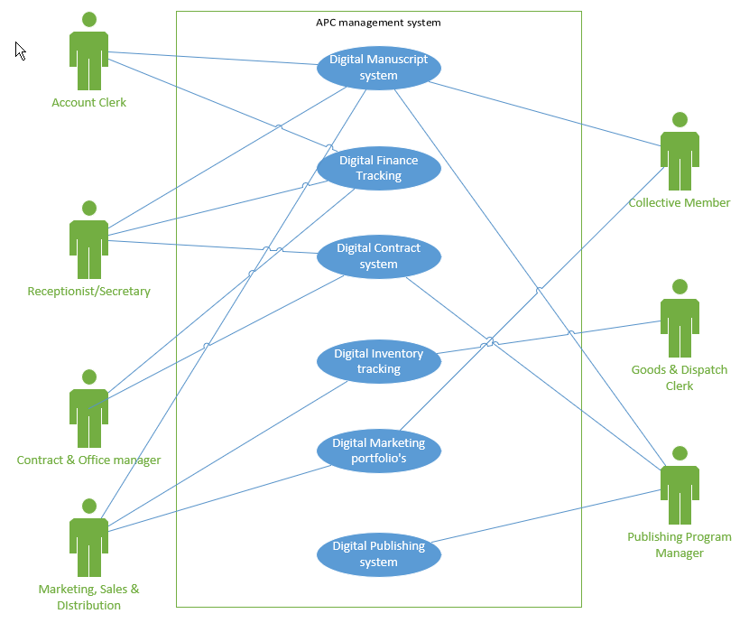

Conclusion

In this assignment I was able to go through the overall plans of APC in detail and review what I had listed previously as general business processes and convert those into function use-cases. This enabled me to get a great idea of what requirements were needed in order to solve the problems that I outlined in the system request and business goals.

From the exercise I learned a lot about how you need to explore every aspect of a system in order to improve it. As mentioned above there are many areas where stakeholders want similar requirements and objectives. Showing this allows for a system designer to see the connection and design a system that tailors to that overlap and could possibly make the system more efficient.
Outlining the use-cases and having to create systems to cover multiple processes gave me a great idea on what it would be like to solve real business problems. There are always other options and this assignment showed that a single system can often be tweaked and changed a little to fit other needs not necessary outlined for that system.

